MILESTONE 4

1. Milestone Overview
Milestone 4 is titled “Creation Of reports & dashboards”. It creates reports from the Employee Test table and combines the reports into the Employee Analytics Dashboards dashboard.
Milestone Detail | Value
Milestone 4 | Creation Of reports & dashboards
Project | Import Data using Transform Maps (Spreadsheet)
Complexity | Medium
Duration | 40m
Main work | Create Reports and add Reports to Dashboard

2. Purpose of Reports and Dashboards
The Reports and Dashboards module provides a visual overview of employee data imported into ServiceNow. Reports can display employee information based on Department, Location, and other relevant fields. The dashboard combines these reports into a single view.

3. Create Reports on Employee Test Table
The milestone instructions create three reports:
- Employees by Department
- Employees by Location
- Employee List Report

3.1 Navigation to Reports
- Open All menus and search for Reports.
- Under Usage and governance, select Reports.
- Click New to create a new report.
- Create the three reports described below.

4. Report 1 – Employees by Department
The first report is named “Employees by Department”. It uses Employee Test as the source table and displays employee data grouped by Department.
Field | Configuration
Report name | Employees by Department
Data source type | Table
Table | Employee Test
Report type | Pie chart
Grouping | Department
Aggregation | Count

4.1 Procedure
- Open Reports from Usage and governance.
- Click New.
- Select In Data.
- Enter Employees by Department as the report name.
- Select Table as the source type.
- Select Employee Test and click Next.
- Select Pie chart.
- Configure Count grouped by Department.
- Save the report.
- 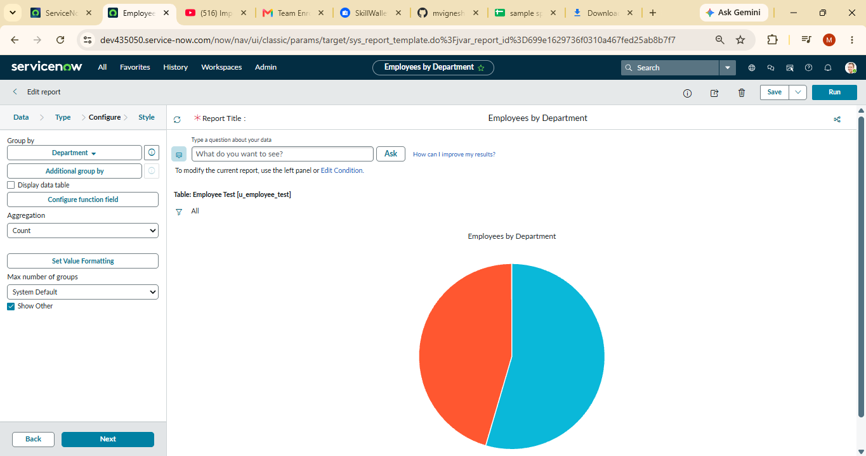

Figure 1: Report creation and Employee Test report configuration

5. Report 2 – Employees by Location
The second report is named “Employees by Location”. It provides a location-wise view of employee records from Employee Test.
Field | Configuration
Report name | Employees by Location
Source table | Employee Test
Report purpose | Location-wise employee information

5.1 Procedure
- Open Reports.
- Create a new report.
- Use Employee Test as the source table.
- Enter Employees by Location as the report name.
- Configure the report using Location.
- Save the report.
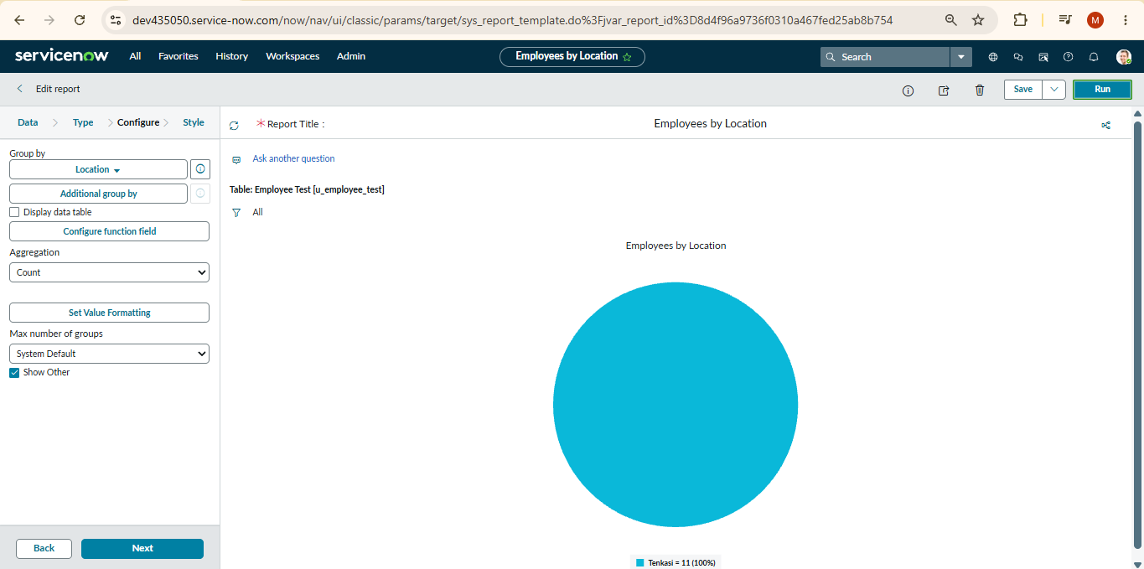

6. Report 3 – Employee List Report
The third report is Employee List Report. It displays employee information as a list.
Field | Configuration
Report name | Employee List Report
Source table | Employee Test
Displayed fields | Employee ID, Employee Name, Email, Department, Location
Report format | List

6.1 Procedure
- Open Reports and select New.
- Select Employee Test as the source table.
- Enter Employee List Report as the report name.
- Select Employee ID, Employee Name, Email, Department, and Location.
- Save the report.

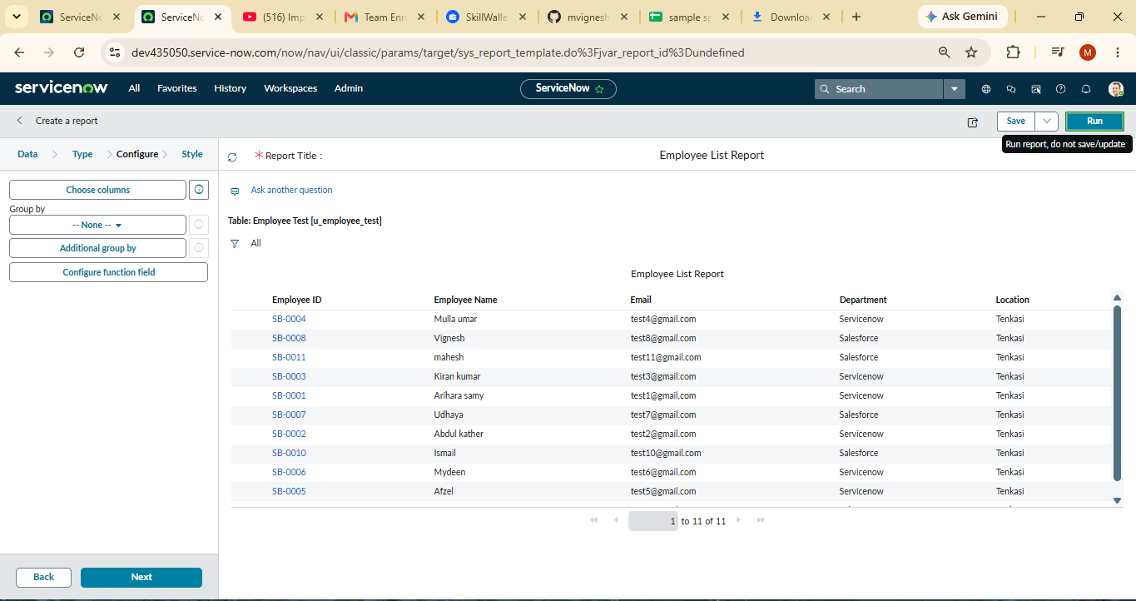

7. Create Dashboard
The dashboard combines the previously created reports into one centralized view. The specified dashboard name is “Employee Analytics Dashboards”.

7.1 Dashboard Navigation
- Open All menus and search for Dashboards.
- Under Self Service, click Dashboards.
- Click Create Dashboards, or use the backend form PA_DASHBOARDS.FORM as specified in the project instructions.
- Click New to create a dashboard.
- Enter Employee Analytics Dashboards as the dashboard name.
- Save the form.

7.2 Backend Form Access
The supplied instructions state that PA_DASHBOARDS.FORM requires the pa_dashboards ACL with Admin Overrides set to True. The instructions describe searching pa_dashboards in the ACL Name column, opening the Create Operation row, enabling Admin Overrides, and updating the form.

8. Add Reports to Dashboard
The three reports are added to Employee Analytics Dashboards using the Share and Add to Dashboards options.

8.1 Employees by Department
- Open Employees by Department.
- Select Edit Report and click Share.
- Select Add to Dashboards.
- Choose Employee Analytics Dashboards.
- Click Add.

8.2 Employees by Location
- Open Employees by Location.
- Click View Report when required.
- Click Share.
- Select Add to Dashboards.
- Choose Employee Analytics Dashboards.
- Click Add.

8.3 Employee List Report
- Open Employee List Report.
- Click View Report when required.
- Click Share.
- Select Add to Dashboards.
- Choose Employee Analytics Dashboards.
- Click Add.

8.4 Additional Dashboard Options
The instructions state that widgets can also be added using the + icon and that the dashboard background color can be configured if required.

9. Final Dashboard Content
No. | Report | Purpose
1 | Employees by Department | Department-wise employee report
2 | Employees by Location | Location-wise employee report
3 | Employee List Report | Employee information in list format
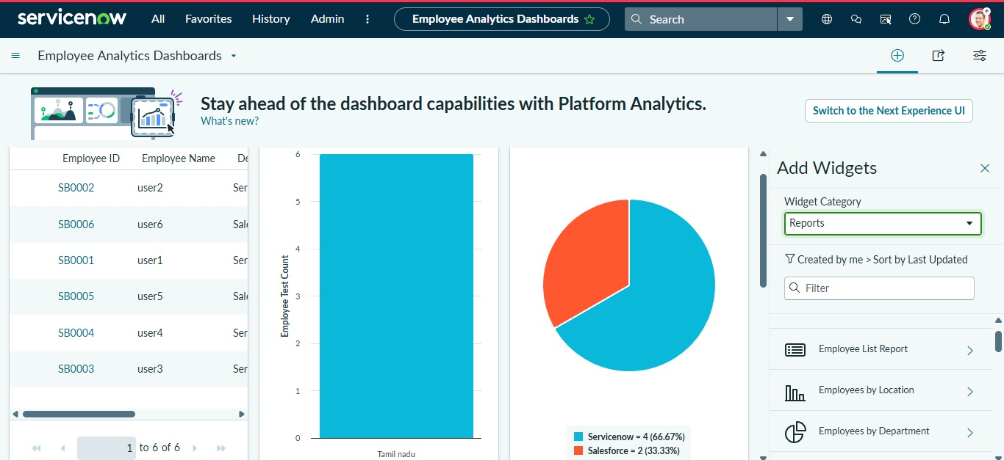
Figure 2: Dashboard/report milestone instructions
The three reports are added successfully to the created dashboard, providing views based on Department, Location, and the employee list.

10. Sharing and Access Control
The supplied instructions state that reports can be restricted from the Share option. Users, Groups, and Roles can be controlled through the sharing settings.

11. Milestone 4 Validation Checklist
☐ Employees by Department report created using Employee Test.
☐ Employees by Location report created.
☐ Employee List Report created.
☐ Employee Analytics Dashboards dashboard created.
☐ Employees by Department added to the dashboard.
☐ Employees by Location added to the dashboard.
☐ Employee List Report added to the dashboard.
☐ Widgets can be added through the + icon when required.
☐ Dashboard sharing restrictions can be configured for Users, Groups, and Roles.

12. Conclusion
Milestone 4 completes the Reports and Dashboards part of the project. Employee Test is used as the source for Employees by Department, Employees by Location, and Employee List Report. These reports are added to Employee Analytics Dashboards to provide a centralized view of employee information.
The milestone instructions also provide options for adding widgets, configuring the dashboard background, and restricting report access through Users, Groups, and Roles.

